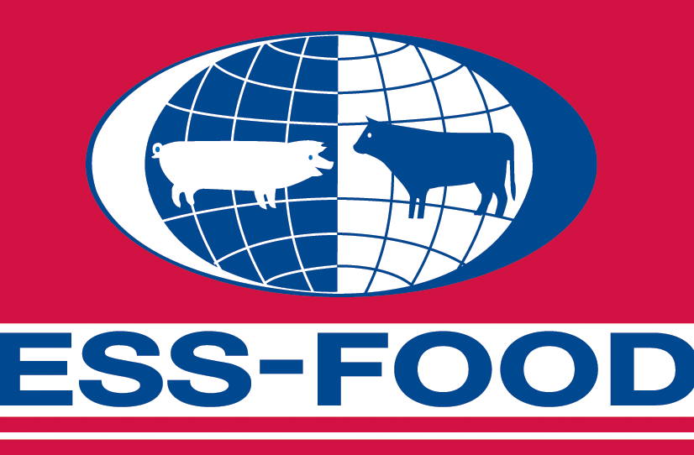

TO WHOM IT MAY CONCERN

Brøndby, September 2007

DAT-SCHAUB International changes name to ESS-FOOD

As of October 1 2007 DAT-SCHAUB International changes name to ESS-FOOD.
This is done to increase the knowledge to the group’s international trading activities.

- ESS-FOOD is a far more well-known brand within international meat trade, and ESS-FOOD is known world-wide for quality and credibility, which are core values we too vouch for and thus we find it only natural for us to use the name, says Morten Holm, managing director in DAT-SCHAUB International.

In 2002 the original DAT-SCHAUB was divided into 2 independent companies, the casings company DAT-SCHAUB amba and the trading company DAT-SCHAUB International.
- The name change also takes place to avoid the confusion we have experienced at times after this division. Some customers have had difficulty in distinguishing between the casings company and the trading company as the two companies continued with the closely associated names, says Morten Holm.

Today the ESS-FOOD name is also used by Danish Crown’s French subsidiary, ESS-FOOD France, which will continue unchanged as an independent subsidiary in the Danish Crown group.

For further information:

Managing director Morten Holm, DAT-SCHAUB International, phone: +45 4346 9001

The new ESS-FOOD is a subsidiary in the Danish Crown group and trades with food worldwide. ESS-FOOD’s registered address is in Brøndby and the company has 13 representative offices worldwide. The company has 110 employees and has an annual turnover of DKK. 2.4 billion.

